**EXERCISE 3 – CALORIMETRY**

Specific Heat Capacity, cH2O is 4.18 J/g ºC

1. Calculate how many joules are needed to warm 25.5 grams of water from 14ºC to 22.5ºC.

2. Calculate the number of joules released when 75.0 grams of water are cooled from 100.0ºC to 27.5ºC.

3. 1.13 x 104 J of heat is added to a water sample and the temperature rises from 88.0 ºC to 100.0 ºC. Calculate the mass of water in the sample.

4. In a calorimetry experiment, 0.1277 g of Mg ribbon was added to 200 g of 0.500 M HCl at 24.12 °C. The water temperature increased to 27.10 °C.

1. Calculate the amount of heat released by the reaction (Q). $$q=\left(0.1277+200\right) ⋅ 4.184⋅2.98=2495.2562 J$$
2. Calculate the change in enthalpy (ΔH) per gram of 0.500 M HCl.

5. A 70.0 g sample of caesium is sealed in a glass vial and lowered into 250.0 mL of water at 90.00 °C. When the caesium had melted, the temperature of the water had dropped to 88.98 °C.

1. Calculate the amount of heat released by the reaction (Q). $$q=\left(70.0+250.0\right) ⋅ 4.184⋅1.02=1365.6576 J$$
2. Determine the change in enthalpy (ΔH) per gram of 0.500 M HCl.

6. An experiment was done to determine the energy held within different types of food at 25oC and 1 atm. Each type of food (3g) was set on fire under a test tube containing 15 mL of water. The temperature was recorded after the food had finished burning.

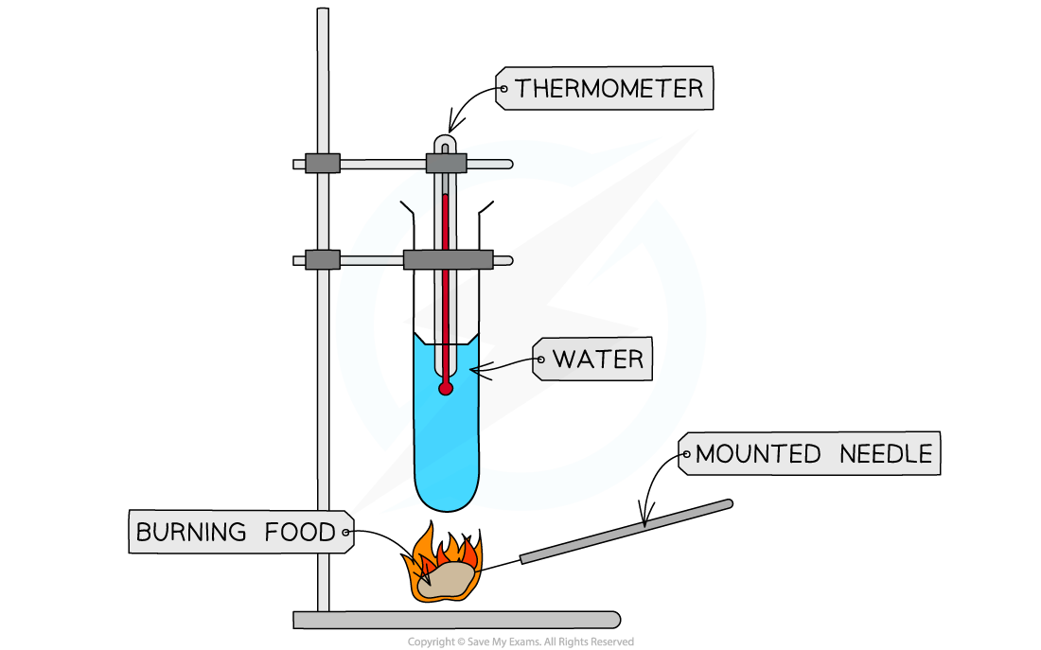

Table 1 shows the results from the experiment:

|  |  |  |  |  |
| --- | --- | --- | --- | --- |
| Food Type | Initial Water Temperature (˚C) | Final Water Temperature (˚C) | Experimental Enthalpy of Combustion (kJ/g) | Energy from the Packet (kJ/g) |
| Popcorn | 24.9 | 63.0 | 0.797 | 20.7 |
| Pasta | 25.1 | 52.4 | 0.571 | 15.3 |
| Twisties | 25.0 | 67.3 | 0.885 | 19.4 |

1. Complete the table by calculating the experimental enthalpy of combustion for each food.
2. Compare the experimental enthalpy of combustion with the energy content reported on the packet. Suggest a reason why they might be different.  
   The values for experimental enthalpy of combustion are much lower than the energy content reported on the food packaging, shown by the calculated enthalpy for . A likely reason for this is that the energy on the packet is the chemical potential energy of the food, and burning the food transforms this energy into heat, with a large amount being lost to the surroundings due to the experiment not being insulated. This lack of insulation reduces the amount of heat energy being absorbed by the water, therefore making the calculated experimental enthalpy of combustion lower than the value listed on the packet.

7. An experiment was done to determine the heat of combustion of four different fuels at 25oC and 1 atm. Each liquid fuel heated 10 g of water by 10oC. The fuels were weighed before and after the experiment to record the mass of fuel combusted.

Experiment setup:

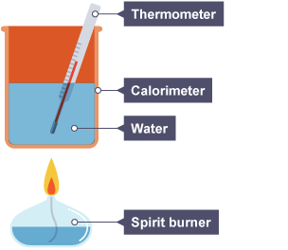

Results from the experiment are shown in the table:

|  |  |  |  |
| --- | --- | --- | --- |
| Fuel | Mass of Fuel Combusted (g) | Experimental Enthalpy of Combustion (kJ/g) | Theoretical Enthalpy of Combustion (kJ/g) |
| Ethanol | 16.7 |  | -29.7 |
| Propanol | 14.5 |  | -33.6 |
| Butanol | 13.9 |  | -36.2 |

1. Complete the table by calculating the experimental enthalpy of combustion for each fuel.
2. Compare the experimental enthalpy of combustion with the theoretical enthalpy of combustion. Suggest a reason why they might be different.